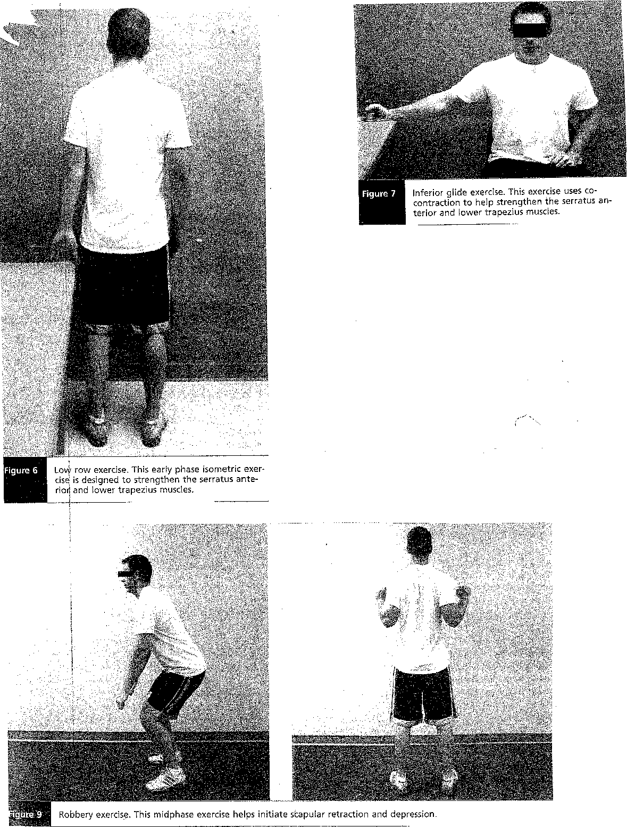
Inferior glide exercise. This exercise uses co-contraction to help strengthen the serratus anterior and lower trapezius muscles.
Lovt row exercise. This early phase isometric exer-cis is designed to strengthen the serratus ante-rio and lower trapezius muscles.
Robbery exercise. This midphase exercise helps initiate scapular retraction and depression.
Figure 6

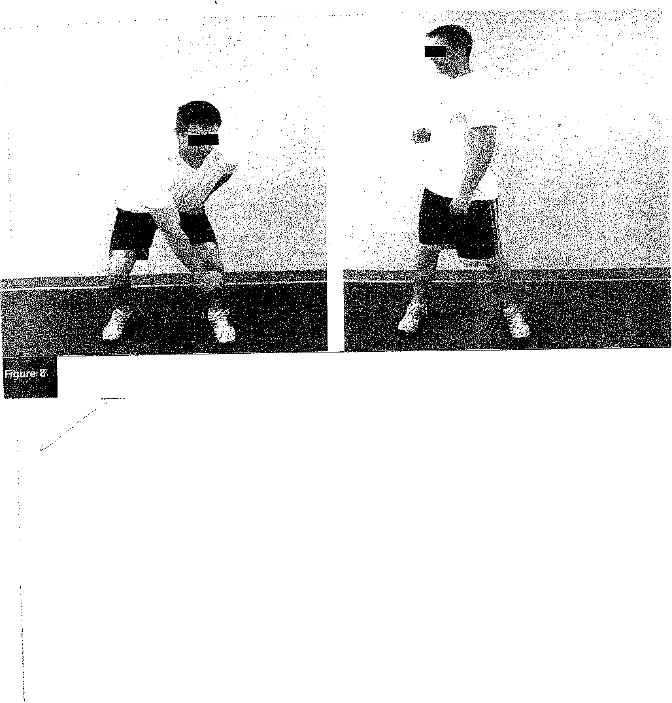
Lawnmower exercise. This dynamic maneuver strengthens the scapular stabilizers by using multiple kinetic chain segments.

