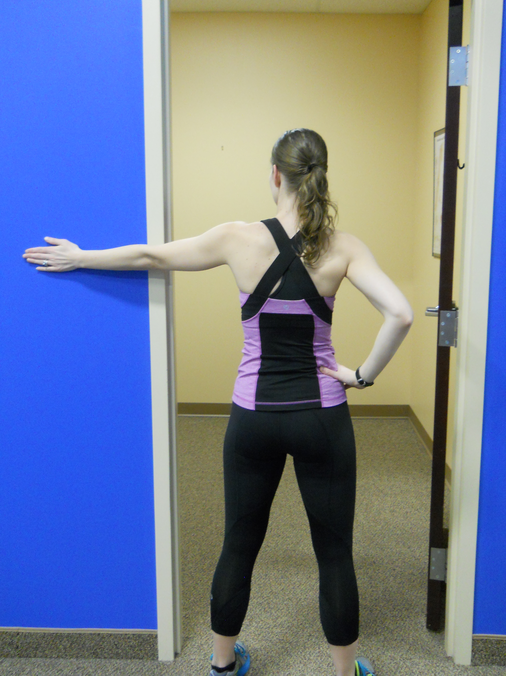
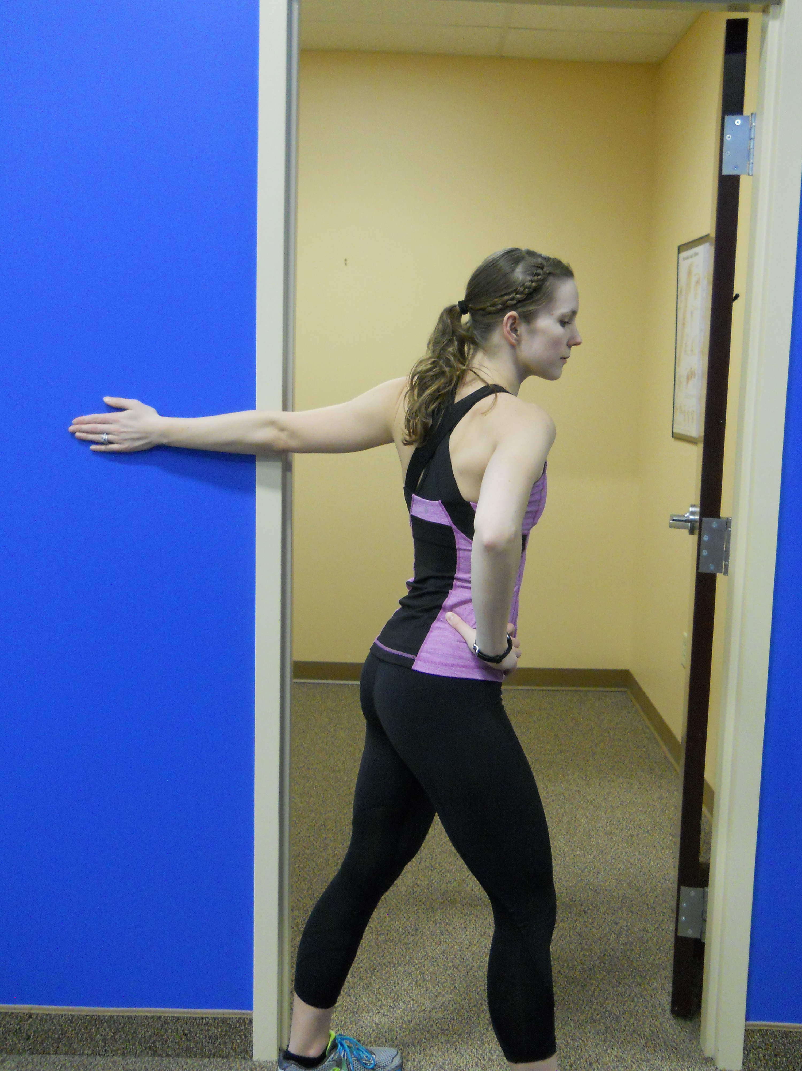
PEC MAJOR STRETCH

Place palm of right/left hand on wall. Gently turn right/left until you feel a stretch in the front of chest/ shoulder. Hold 3-5 seconds.
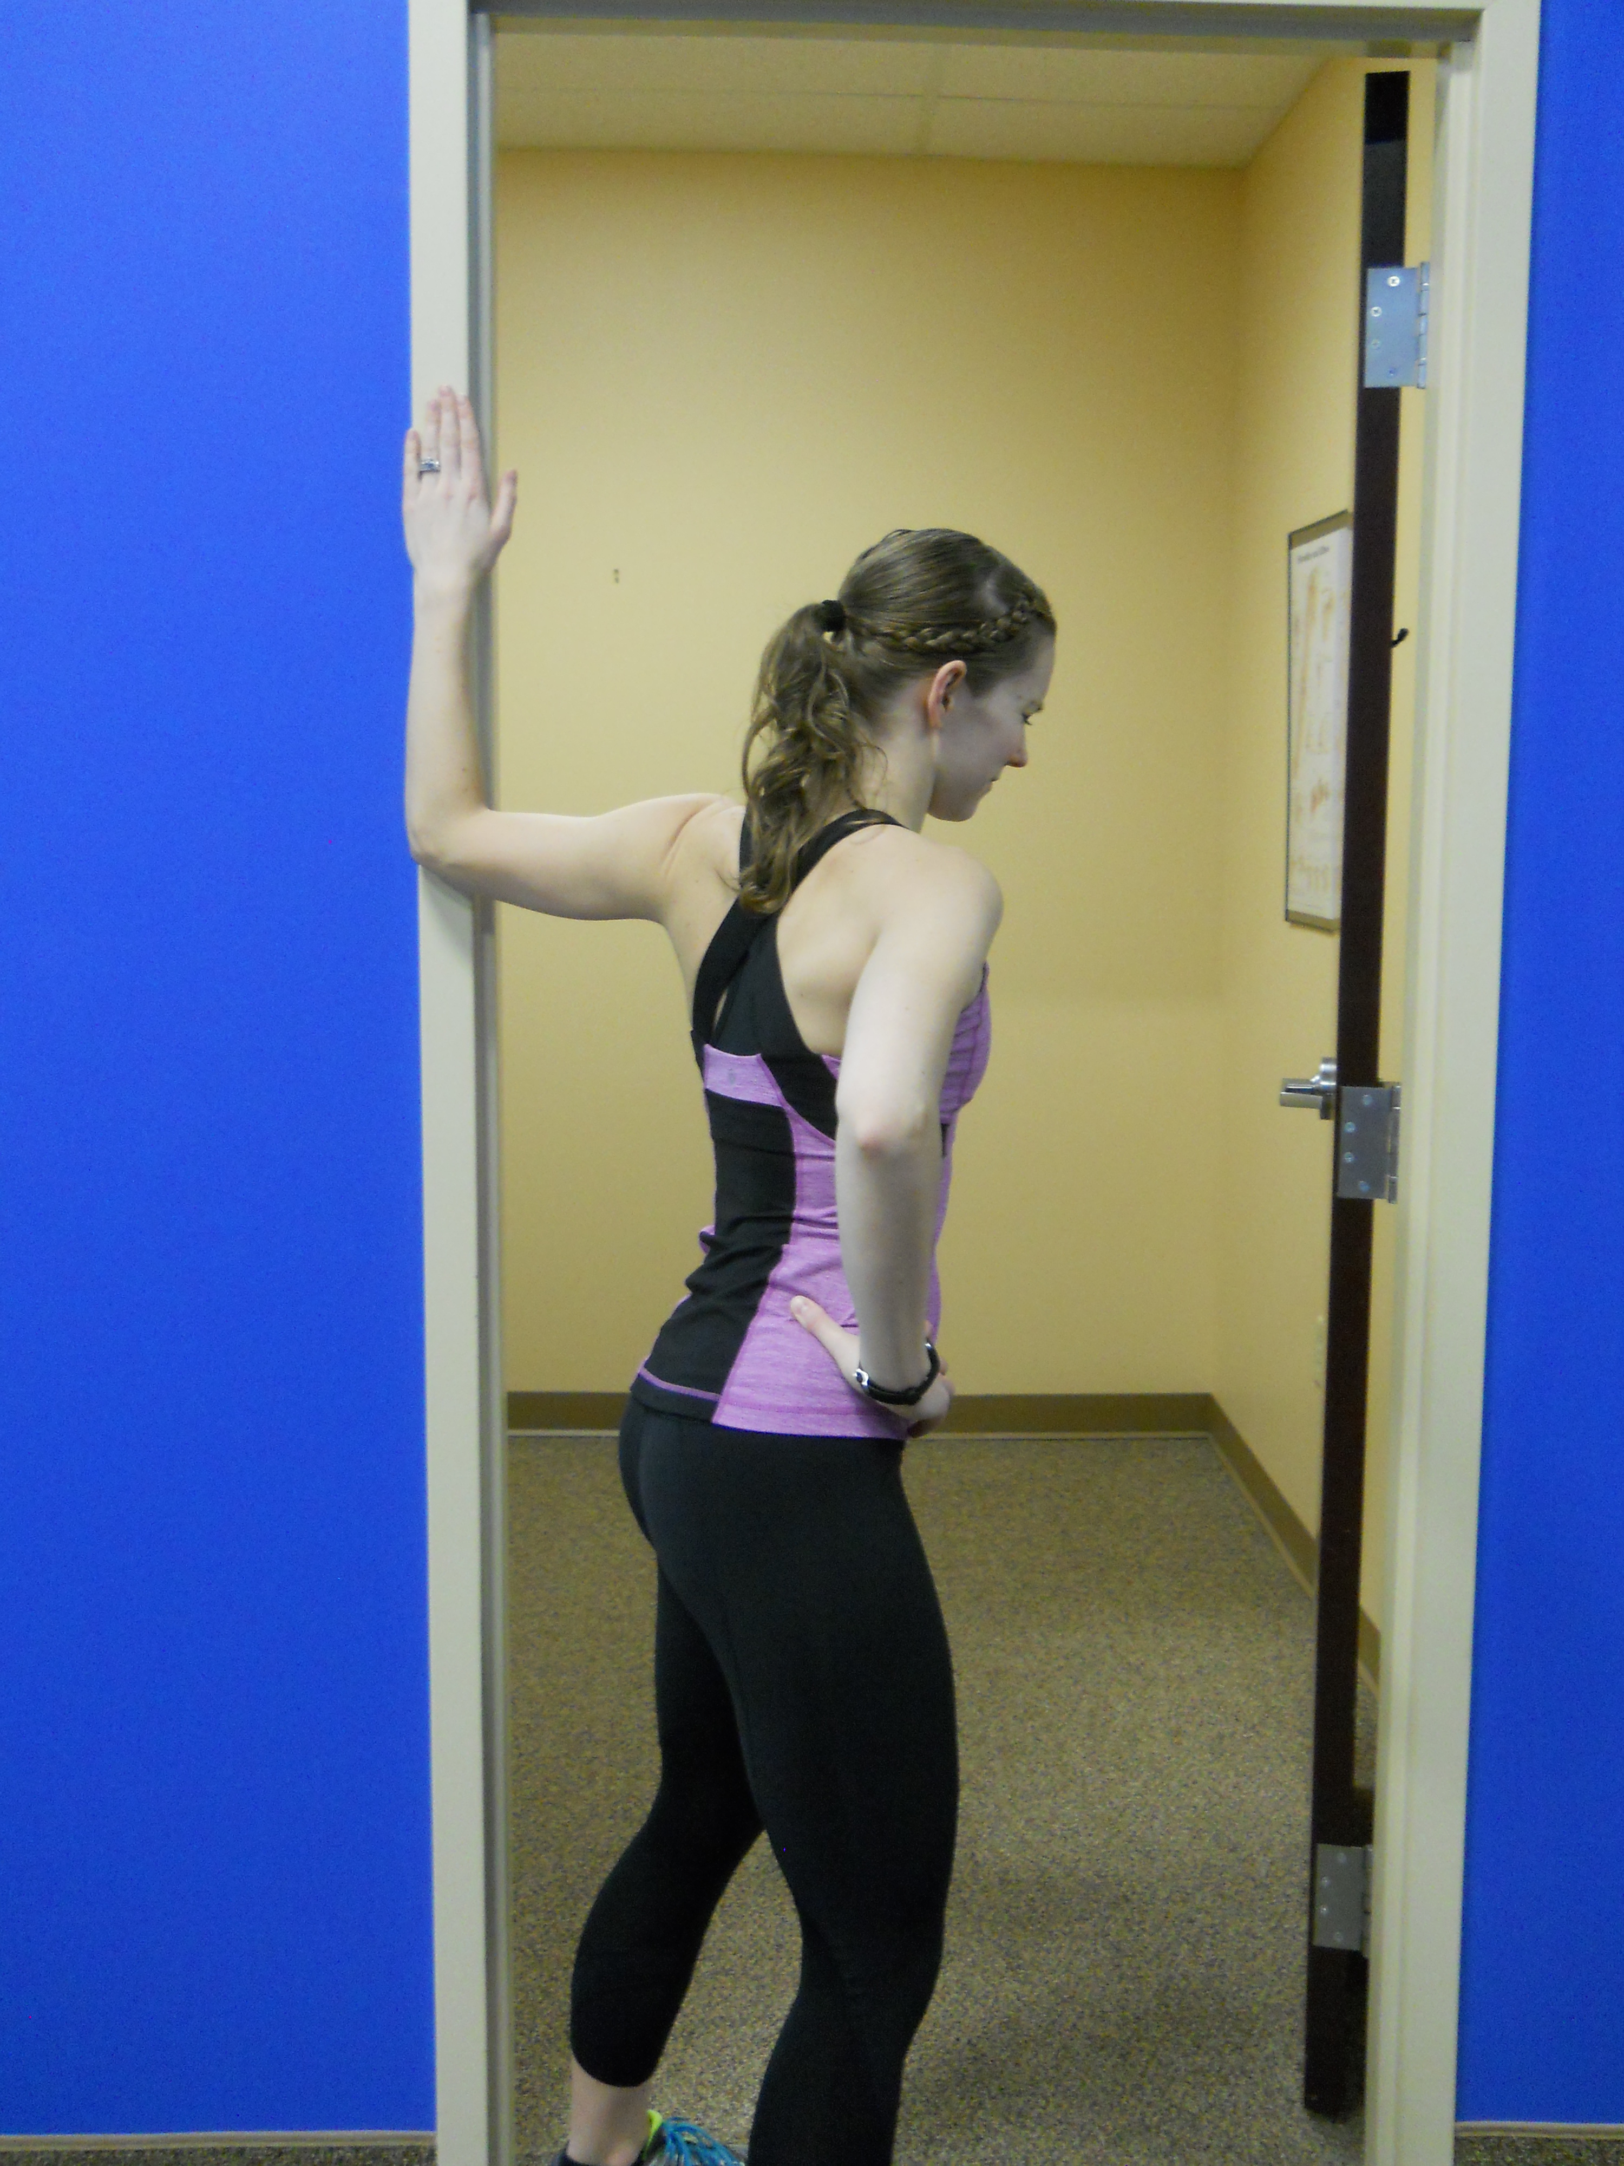
Repeat 10-15 times___times/day. PAIN FREE RANGE.
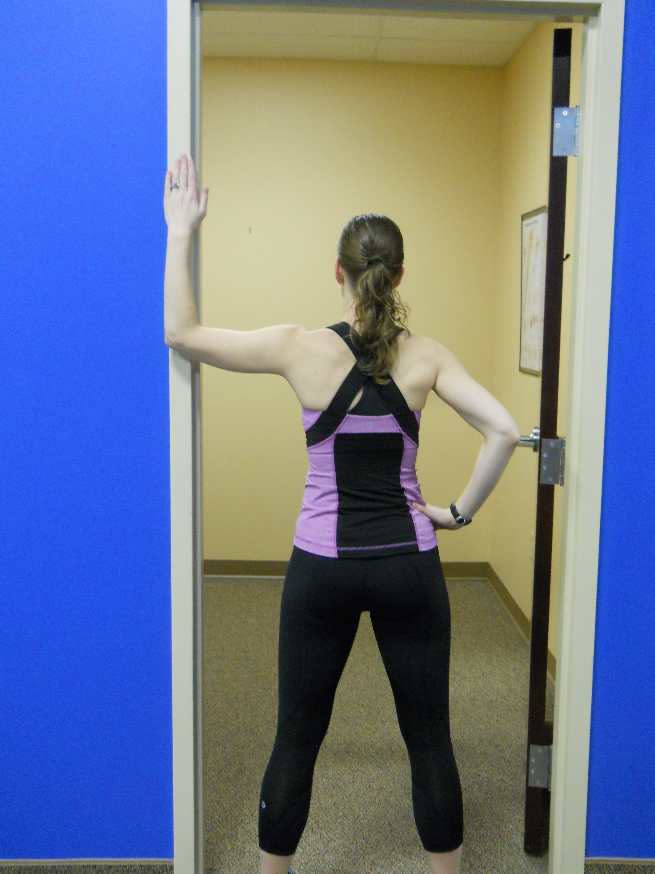

PEC MINOR STRETCH

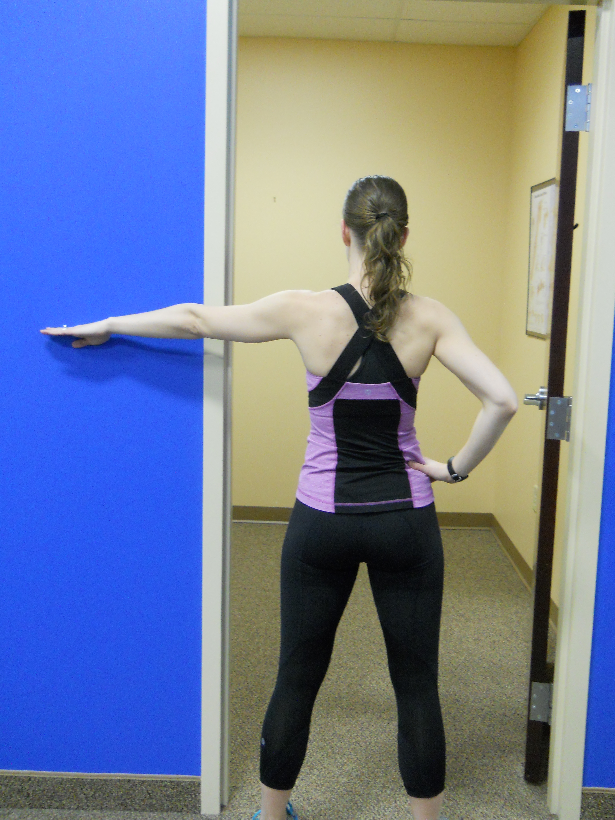
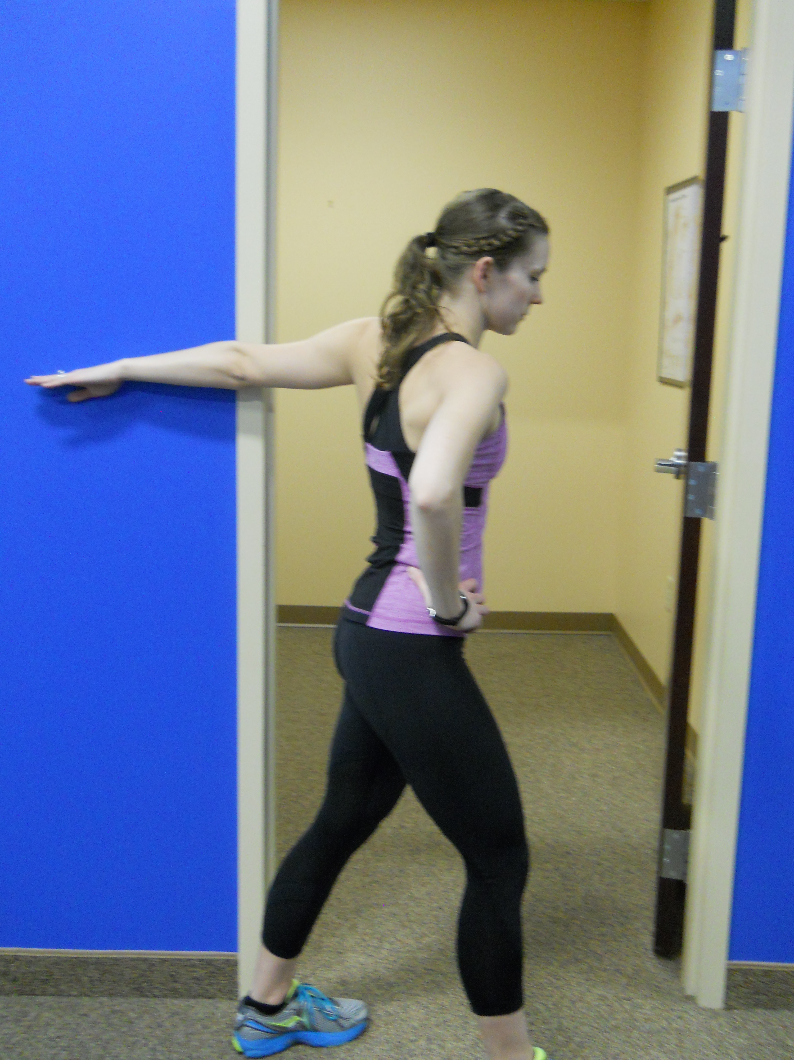
Place palm of right/left hand flat on wall higher than shoulder. Gently turn right/left until you feel a stretch in the front of chest /shoulder. Hold 3-5 seconds. Repeat 10-15 times___times/ day.

BICEP STRETCH

Place side of right/left hand on the wall. Gently turn right/left until you feel a stretch in front of arm. Hold 3-5 seconds. Repeat 10-15 times.

