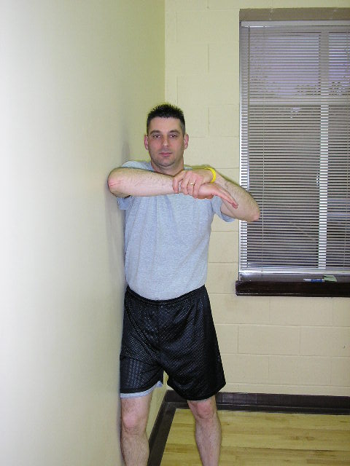
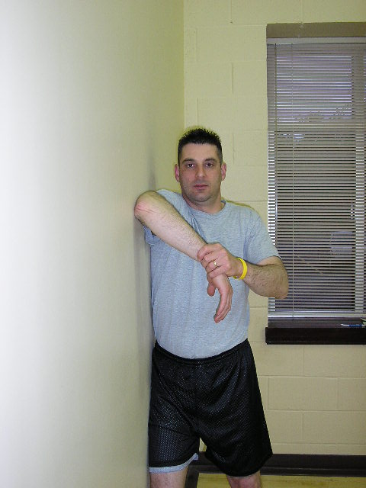

STANDING
POSTERIOR CAPSULE STRETCH

Stand with your left/right side to the wall. Position your shoulder and elbow against the wall at 90 degrees. Place the opposite hand on the wrist and gently push and rotate hand toward the floor. Feel a mild stretch in the back of your shoulder. Hold 3-5 seconds. Repeat 10-15 times___times/day. PAIN FREE RANGE.
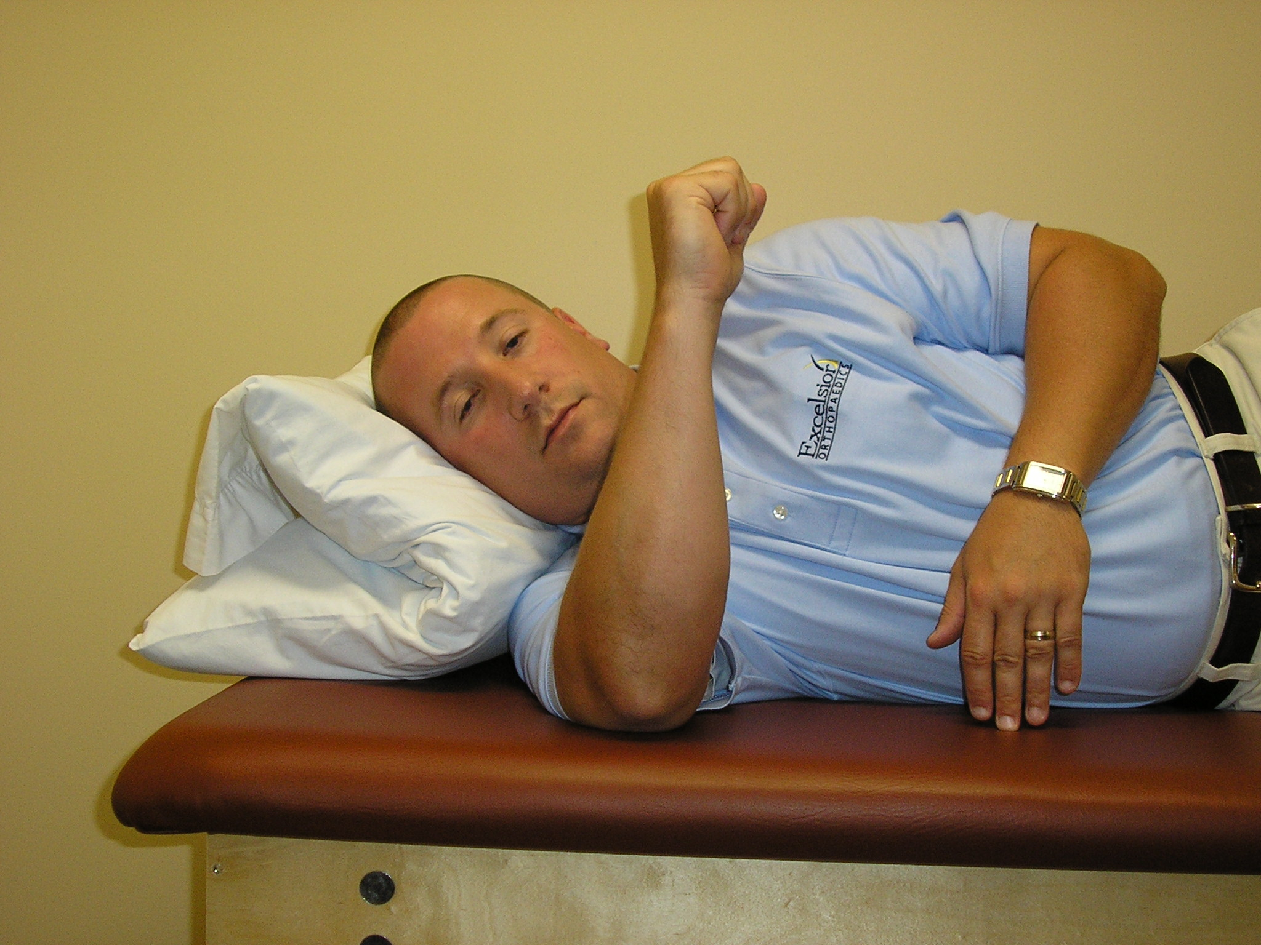
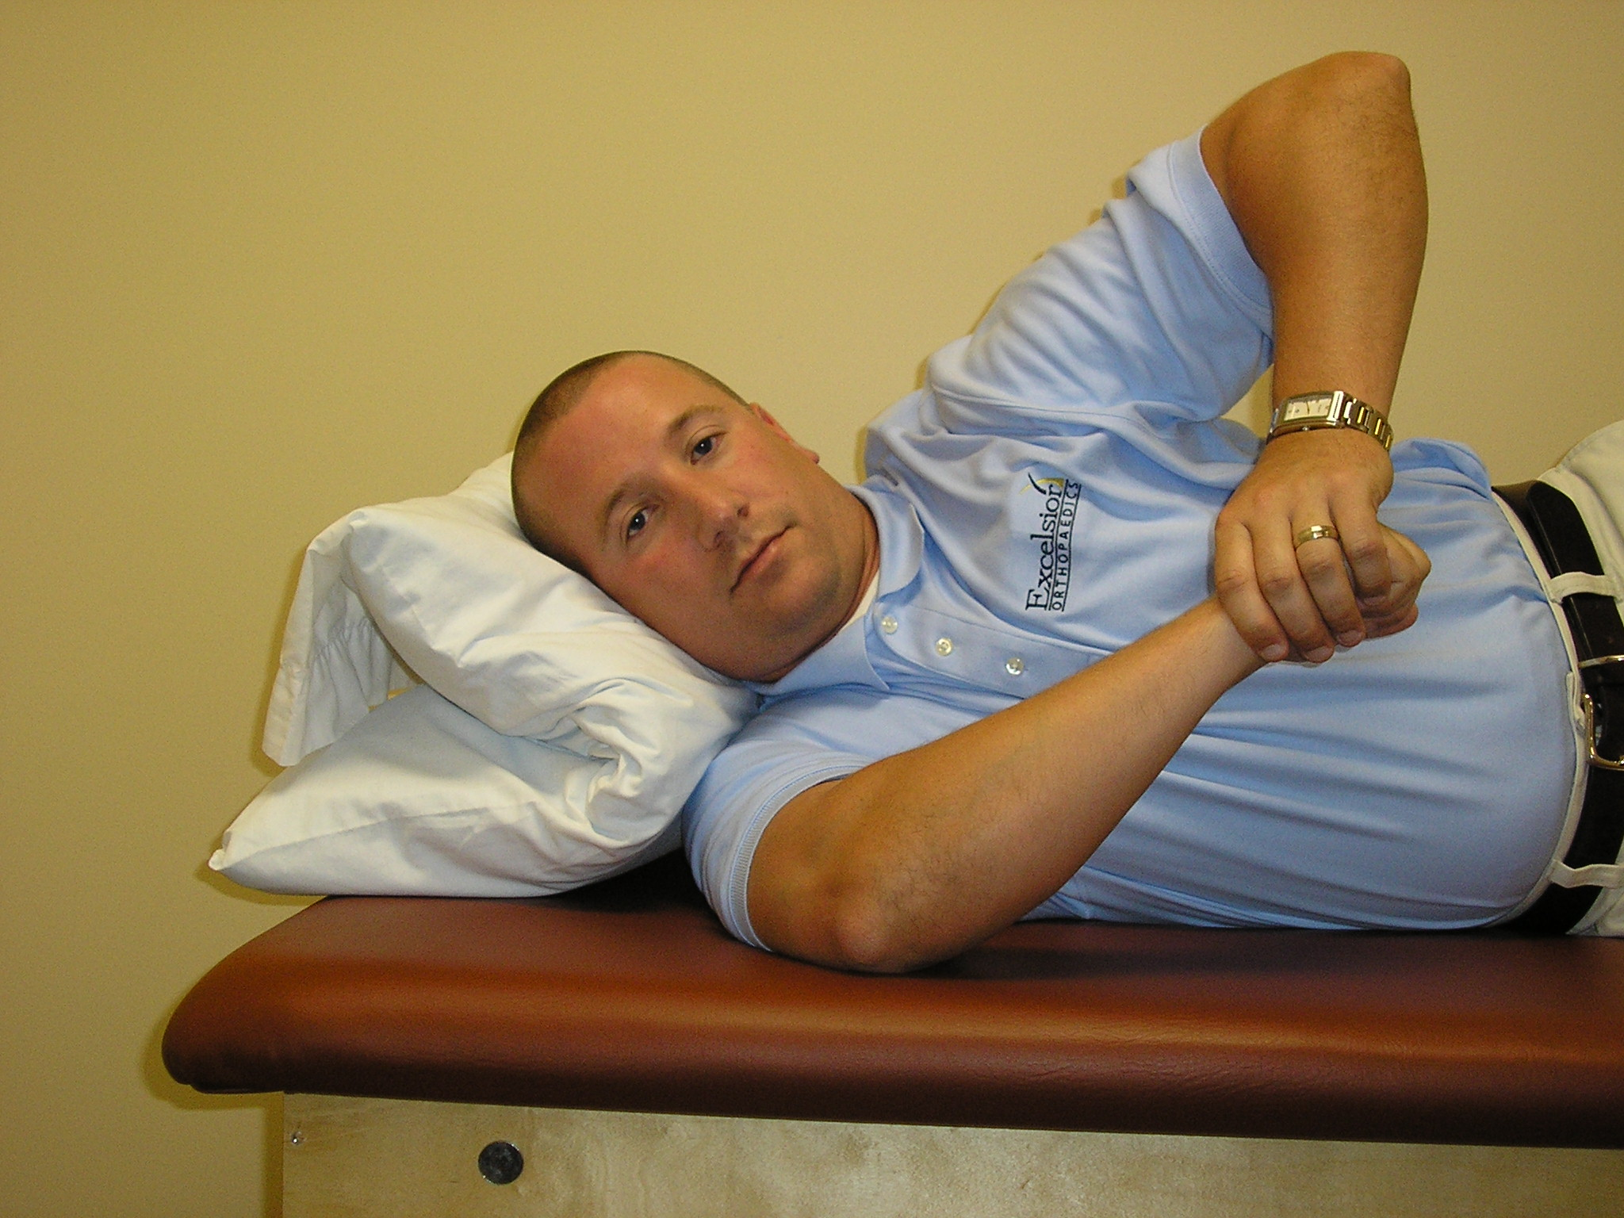

SIDELYING
POSTERIOR CAPSULE
STRETCH

Lying on your left/right side, position your shoulder and your elbow at 90 degrees. Place your left/right hand on the wrist of the affected arm. Gently pushing and rotating the hand down towards the table.
Feel a mild stretch in the back of left/right shoulder. Hold 3-5 seconds. Repeat 10-15 times___times/day. PAIN FREE RANGE.

